Dobro jutro, dragi moji!
Danas imamo hrvatski, matematiku i glazbeni.
Želim vam ugodan dan!
Želim vam ugodan dan
4.5.

JIOJIDJ
HRVATSKI JEZIK
Provjera lektire Mama je kriva za sve.
Ispod se nalazi listić. Prepiši naslov i ime književnika u bilježnicu. Prepiši pitanja i odgovori na njih. Kada riješiš sve pošalji mi sliku.

Glazbena kultura
29.4. je bio Svjetski dan plesa, pogledaj kako se pleše u pojedinim zemljama. Otvori poveznicu i klikni na + https://view.genial.ly/5ea2204cd407580db9f07375/interactive-image-svjetski-dan-plesa-294?fbclid=IwAR3mTN5FR4h_S7tJLEk-ECWlgMNeUTckqCOnaK9YFIxzGybg2CKfrMT4vEM

MATEMATIKA

Riješi ponovimo na str. 82 u udžbeniku.
Danas ćemo naučiti crtati pravokutnik i kvadrat koristeći se geometrijskim priborom pa si pripremi trokute i šestar.
Pogledaj prikaz crtanja pravokutnika i kvadrata u svome udžbeniku na 82. stranici.

Vjerujem da ćeš ti u tome uspjeti. A za malu pomoć pogledaj video . U google zalijepi link. https://m.youtube.com/watch?feature=youtu.be&v=-L13kLHzTyQ

Napiši u bilježnicu naslov i nacrtaj:

TJELESNA I Danas zapleši i protresi cijelo tijelo
Crtanje pravokutnika i kvadrata

Nacrtaj pravokutnik i kvadrat po želji, slično ovome.
a
a

b
b
a
a

a
a

pravokutnik kvadrat

a = 4 cm a = 45 mm
b = 35 mm
a
a

a
a
b
b

Riješi radnu bilježnicu na 96. stranici i svoj uradak mi pošalji na pregled.

Hrvatski jezik
Djelo: Mama je kriva za sve

Pisac: Zoran Pongrašić

VRSTA: PRIPOVIJETKA BAJKA DJEČJI ROMAN IGROKAZ
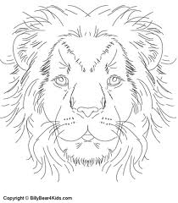
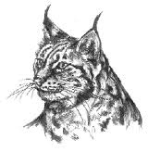
TEMA: _______________________________________________________________________________
MJESTA RADNJE: ______________________________________________________________________
VRIJEME RADNJE: __________________________________________
Glavni lik:
BE ____________________________________
Osobine: _________________________________________________________________________________
Ostali likovi: _____________________________________________________________________________
_____________________________________________________________________________
Nacrtaj po čemu su lopovi dobili nadimke.
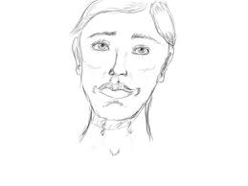
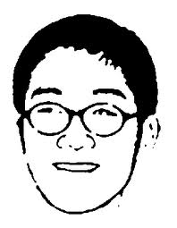

__________________ ______________________
Prepiši opis blizanki: ________________________________________________________________________
__________________________________________________________________________________
__________________________________________________________________________________
__________________________________________________________________________________
U osmosmjerci pronađi i oboji likove: BAKA, MIRELA, STELA, BRANKA, ARČI, OŽILJAK, KRANJEC, BRADA, EUGEN i FRANJO.
A | K | A | B | S | P | O | K
I | Č | R | A | T | B | Ž | R
O | L | F | I | E | R | I | A
M | I | R | E | L | A | LJ | NJ
C | A | A | U | A | D | A | E
J | A | NJ | G | C | A | K | C
 | M | O | E | I | L | I | C
B | R | A | N | K | A | A
Ostala slova su likovi: _______________________________ i
_____________________________________.
Ukratko opiši najsmješniji događaj.
__________________________________________________________________________________
__________________________________________________________________________________
__________________________________________________________________________________
__________________________________________________________________________________
__________________________________________________________________________________

__________________________________________________________________________________
__________________________________________________________________________________
__________________________________________________________________________________

