Revision: Unit 3
2 Crossword
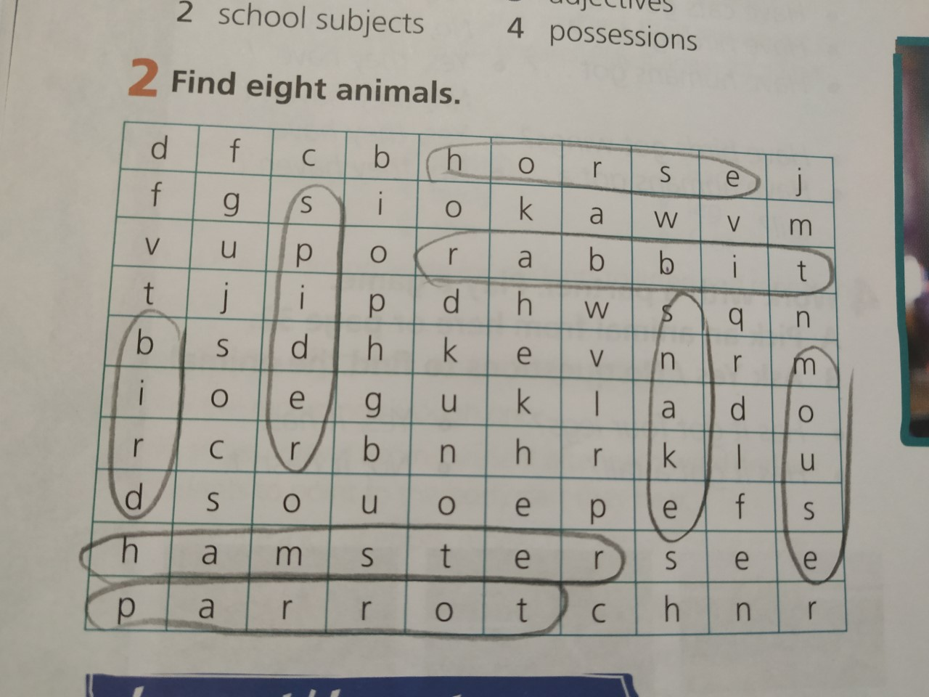

3
I have got a dog. I haven't got a dog.
We have got Science on Wednesday. We haven't got Science on Wednesday.
Our school hasn't got a uniform.
I have got a skateboard. I haven't got a skateboard.
We have got English today.
My best friend has got a pet. My best friend hasn't got a pet.
Our English teacher hasn't got short hair.
I have got blue eyes. I haven't got blue eyes.

4
Have we got Maths on Tuesday?
Has Joe got a sister?
How many legs has a spider got?
Has a crocodile got feathers?
Has our teacher got a bike?
Have you got a red bag?
What subjects have we got today?
Have you got a pet?
5
Edward has got a mobile phone, a dog, a model car, a brother.
Edward hasn't got a skateboard, a bike, a DVD player, a television, a radio.
Martha has got a bike, a mobile, a DVD player, a television, a radio, a brother, a model car.
Martha hasn't got a skateboard, a computer, a pet.

